UCLA ASA DataFest 2020 Write-Up
https://teamchisquare.weebly.com/
Team Chi Square: Eustina Kim (kimjee8955@gmail.com), Tiffany Feng (tiffanyfeng456@gmail.com), Diana Pham (dianapham005@gmail.com), and Kienna Qin (kqin@g.ucla.edu)
Our team was interested in studying the relationship between social vulnerability measures and COVID-19 case prevalence in all counties in California. Within the scope of our project, we will be using CDC’s definition of social vulnerability as a measure of the resilience of communities when dealing with external stresses on health, such as age, housing, race/ethnicity, and more.
We compiled five datasets for our analysis: 1) Esri - Definitive Healthcare: USA Hospital Beds, 2) CDC - 2018 Social Vulnerability Index (SVI), 3) County Health Rankings & Roadmaps program - 2020 County Health Rankings National Data, 4) California Department of Public Health - California COVID-19 Hospital Data and Case Statistics, and 5) United States Census Bureau - 2019 County Population Totals.
To create our measure of social vulnerability, our goal was to determine factors related to hospital capacity, specifically the average hospital bed utilization rate in each county of California. Using a multiple regression model, we found a relationship between our stated response variable and five social vulnerability measures: the percent of the population consisting of individuals under age 17, Black individuals, single parent households, crowded households (more people than rooms), and individuals in severe housing situations (indicated by high housing costs or lack of kitchen or plumbing facilities). With our chosen model variables, we calculated a social vulnerability index (SVI) by calculating the sum of the standardized scores of each respective variable.
We created maps to compare the SVI and COVID-19 case rates per county in California:
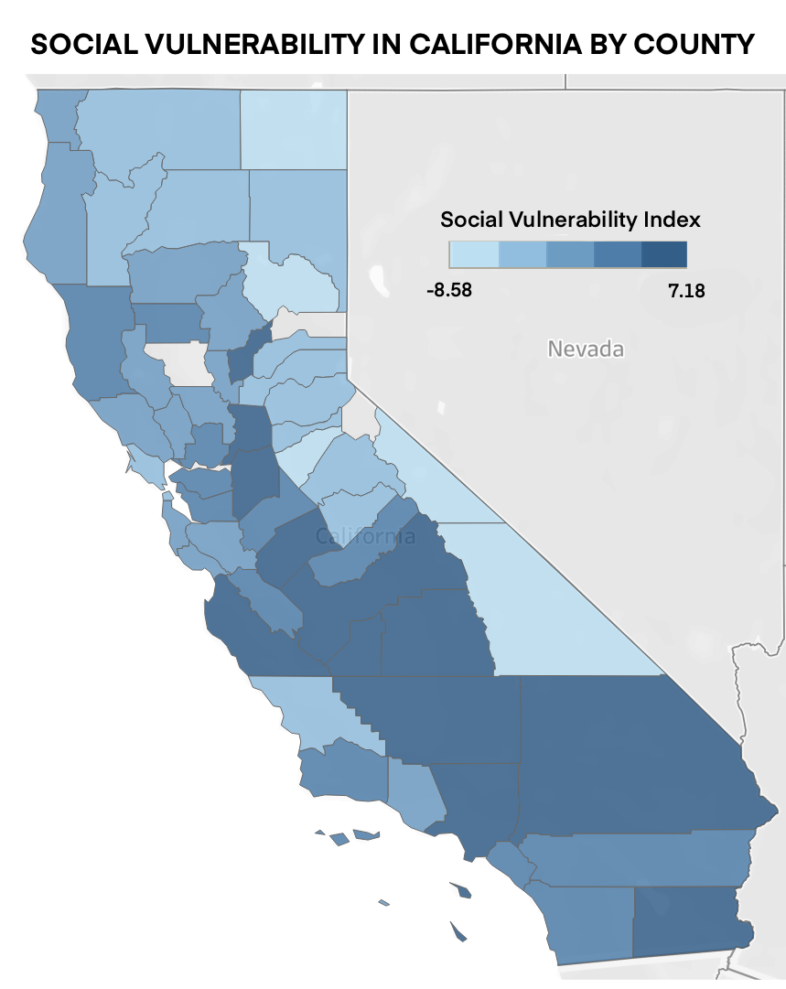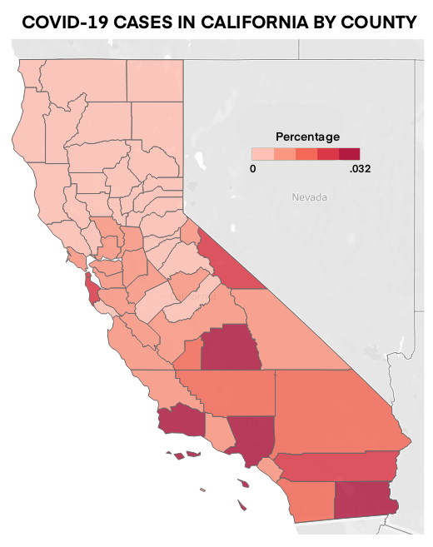
There appears to be a strong relationship between the SVI and COVID-19 case prevalence per county, suggesting that more socially vulnerable counties in terms of age, housing insecurity, and race are less equipped to handle impacts of COVID-19. Thus, more supportive resources should be given to these communities in hopes of more equitable health outcomes in the future. It is important to note that our analysis is limited by a restricted SVI measure with few variables that is not representative of all relevant social vulnerability measures and possible discrepancies in the COVID-19 case rates due to available testing and lack of documentation of false negatives or false positives.

