DataFest Team Covid-20
Airline Companies’ Flight Reduction Strategy during a Global Pandemic
Our team’s DataFest project attempts to investigate factors that shape airline companies’ decision on flight reduction. We downloaded data from one of Federal Aviation Administration (FAA) databases called Traffic Flow Management System Counts (TFMSC). We downloaded the flight operation data for both March 2019 and March 2020 at each one of the 10 busiest airports in the U.S. (by passenger volume 2019). Information on aircraft fuel efficiency and the year of introduction was obtained through a wikipedia webpage. For models of aircrafts that lack fuel efficiency data, we calculated it manually by dividing the range of the aircraft by its fuel tank capacity. The economic profile of the cities was obtained through Bureau of Economic Analysis website.
Overall, our research shows that flight reduction occurred simultaneously across all top 10 U.S. airports around March 21st, 9 days after President Trump announced the travel ban. However, the degree to which the flight reduction affected airports varies. For big and transfer hubs, namely Atlanta and Chicago, flight reduction was more severe than other airports. Atlanta and Chicago both usually have 500 more flights than JFK, DFW, or LAX, but Atlanta’s operation decreased to the same level as DFW. We concluded that large transfer hub airports have more cuts because their loss in transfer passengers is “doubled” compared to O&D airports. We also found that cities with higher tourist ranking experienced larger reductions, as tourism was less resistant to extraneous situations like this compared to business travel. Cities with a large IT sector in its economy exhibit higher resistance to flight reduction.
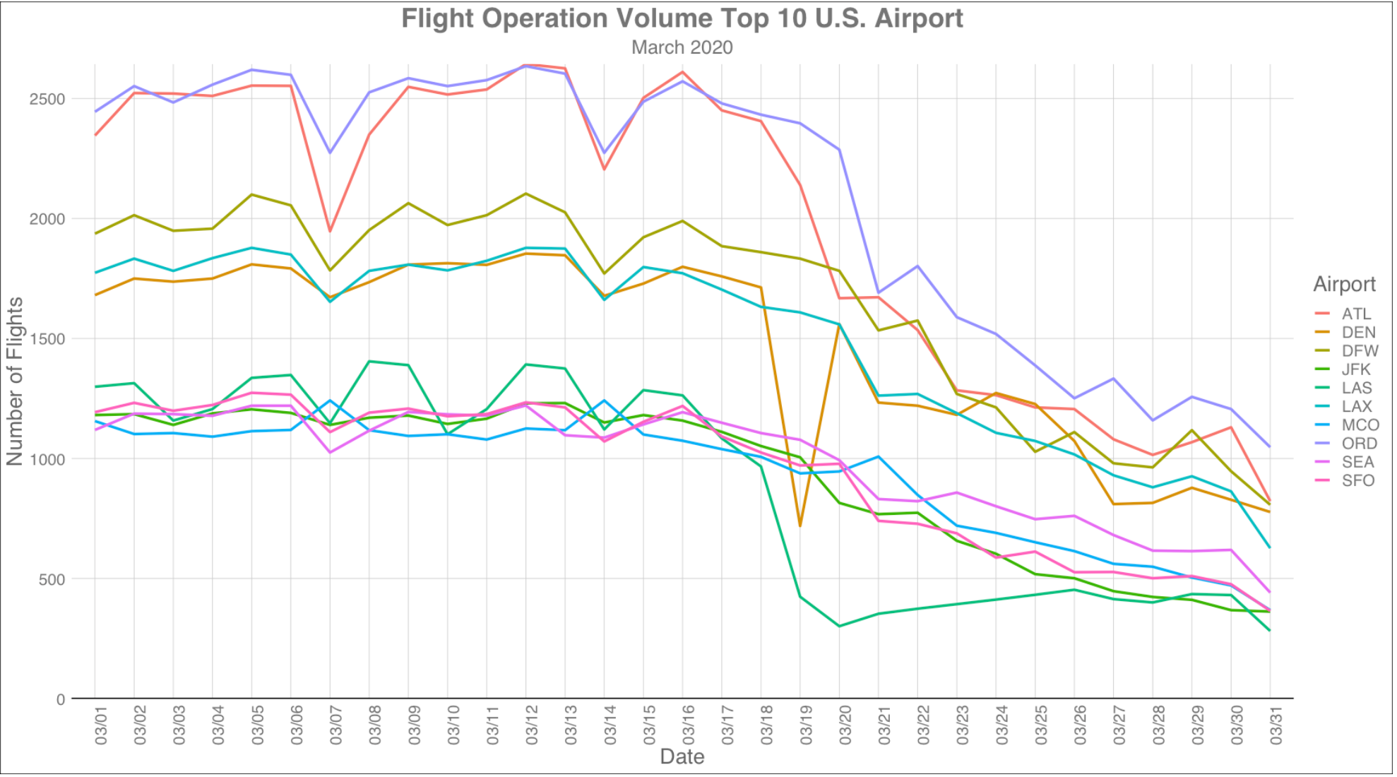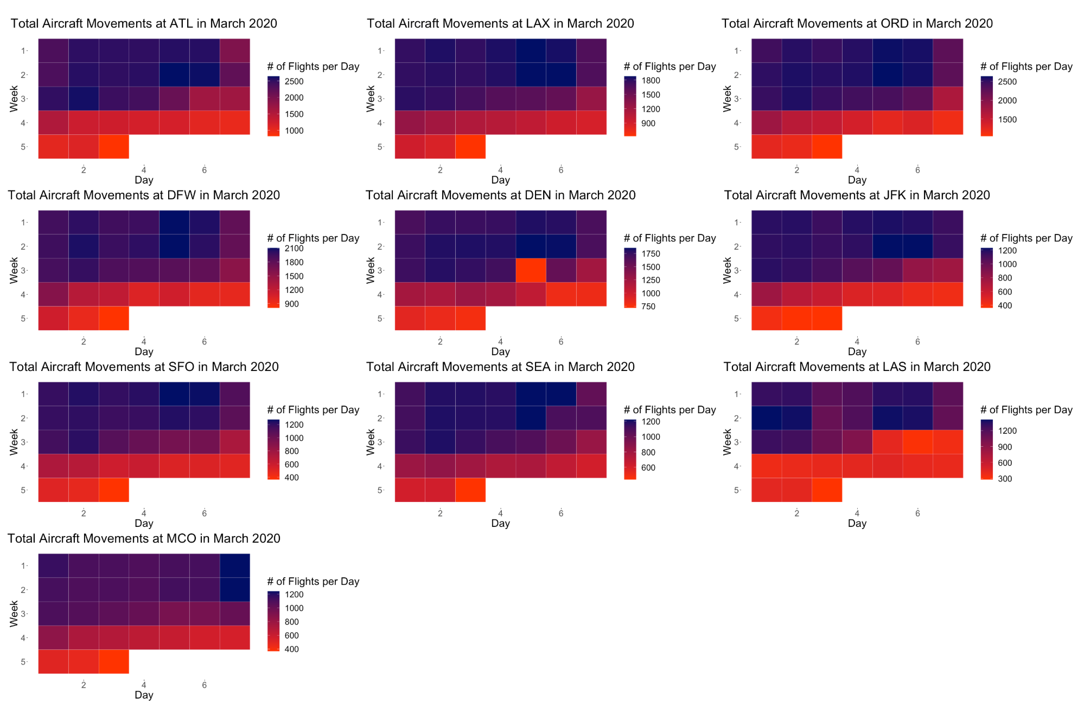
For investigating the role that models of aircraft play in flight reduction, we considered five factors, the market (domestic vs. international), seat capacity, year of introduction, and fuel efficiency. We found the airline companies have a strong preference of using newer models. We see a clear trend that older aircraft models tend to have more flight cuts. In the domestic market, flight reduction in narrow-body aircraft is strongly correlated to their fuel efficiency. We see that airline companies cut more narrow-body jets in the domestic market that are less fuel efficient. Wide-body aircrafts, in both the domestic and international market, demonstrate a positive correlation between their seat capacity and flight reduction. Larger wide-body aircraft with more seats tend to have a bigger reduction in flights.

Links to data sources:
https://aspm.faa.gov/tfms/sys/Airport.asp
https://en.wikipedia.org/wiki/Fuel_economy_in_aircraft
https://www.bea.gov/data/gdp/
https://en.wikipedia.org/wiki/List_of_cities_by_international_visitors
https://en.wikipedia.org/wiki/List_of_United_States_cities_by_population

