Team KSJ
Sophie Yun: sophieyun1229@gmail.com
Ophelia Dong: opheliadong@gmail.com
Yifan Zhao: zyf18@g.ucla.edu

When thinking about COVID-19’s impact on our own lives, we thought of the musicals and concerts that were unfortunately canceled. As a result, we spend more time online looking at our favourite artists’ videos and livestreams and we wonder whether this would be the general case. We looked at the website, VLIVE, which is a Korean live video streaming service that allows celebrities to broadcast live videos and interact with global fans. Our team wants to see how the video views under Kpop category changed amidst this pandemic.
We used the Selenium package to perform the infinite scrolling and the BeautifulSoup to extract data: each video’s initial published date and cumulative views, comments, and likes as of May 11th, 2020. Our cleaned dataset has a total of 444 Kpop channels, 76,866 videos since 2015.
We first looked at the change in mean views three months before and after the worldwide outbreak of COVID-19. We categorized the channels into different groups based on their number of followers. Using February as a cutoff point, we found that the mean views for all Kpop channels increased to a certain degree. Similar trend is also found in likes and comments, so not only are people watching more videos, but they are actively engaging with the content through the comment section.
To put it in context, we looked at how this change compares to the same time period of previous years. Comparing the mean views from February to April from 2016-2020, we could see that the change in mean views seems to follow a random pattern. In general, mean views increased in 2020, but for other years there are big fluctuations. A similar trend is found for comments. Thus, this increase is perhaps not significant and could be just part of the normal fluctuations on Vlive. 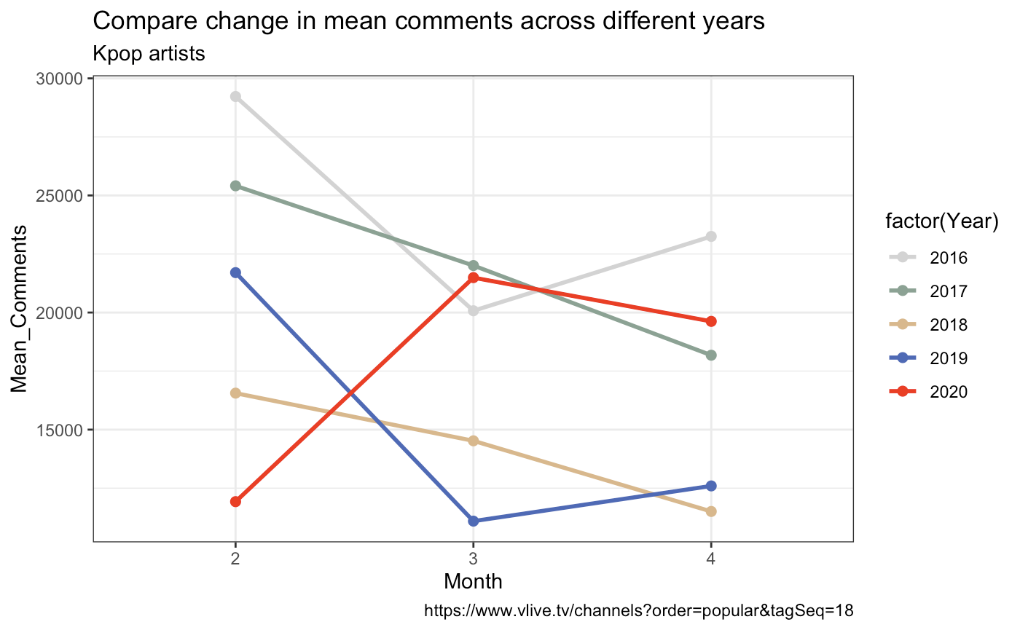
We also looked at the artists’ responses to COVID-19 through the number of videos being posted. We compared 2020’s number of videos again with 2016 to 2019, with dates on the x-axis and the number of videos posted per day on the y-axis. While other years have similar slopes, 2020 has a much steeper one.
In conclusion, the artists on Vlive have been posting more videos during this time of the pandemic. Perhaps they thought that providing more content would be a viable strategy to get more publicity and maintain their fan base. However, the response from fans is ambiguous and needs further investigation

Data resource: https://www.vlive.tv/channels?order=popular&tagSeq=18

