Team: TripleAPlus
Members: Jiayu Lu(leo62022@163.com), Shijie Bian(bian_bsj@163.com)
, Lingyan Dou(doulingyan@outlook.com)
Topic: Covid-19 on Human Mobility

Summary:
Our team has put together data from varies sources. We have mainly focused on four different, yet representative countries – US, Italy, India, and Korea. We first collected the number of confirmed cases for a 76-day period, from Feb 15 to April 30, for each country. Then we grouped them together with their mobility reports on recreation, grocery, parks, transit, workplace and resident, hoping to find a correlation between them, along with their lockdown dates.

Graphs:
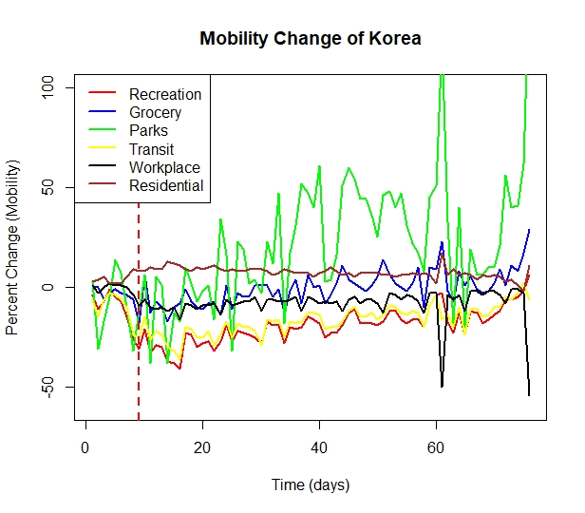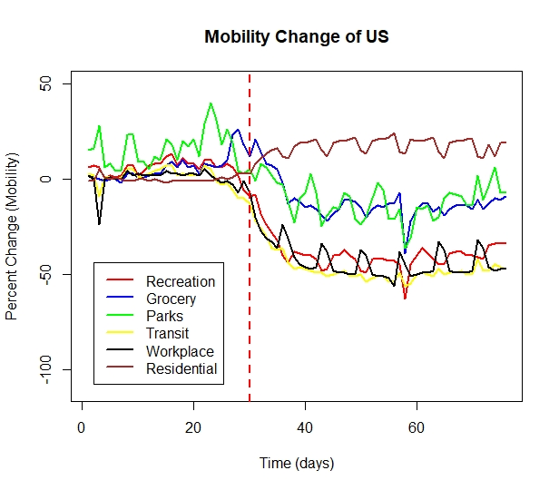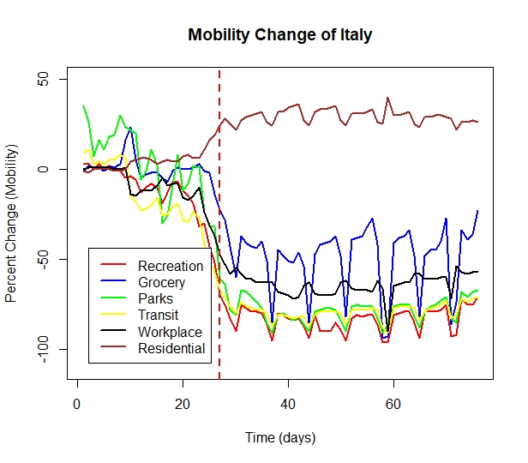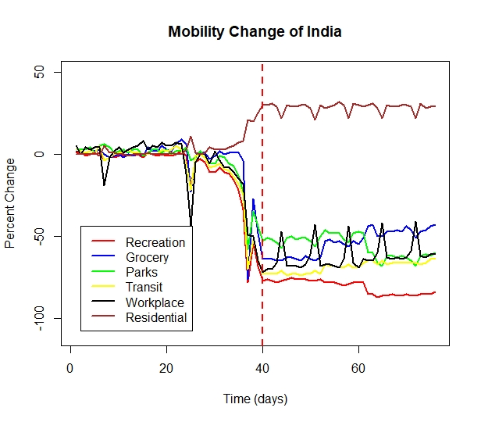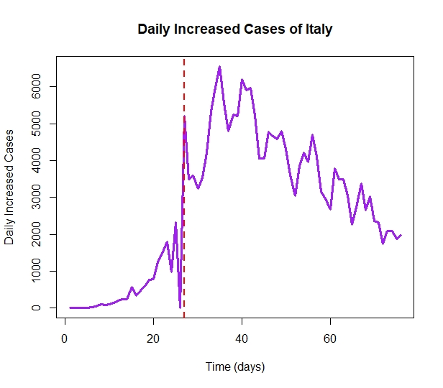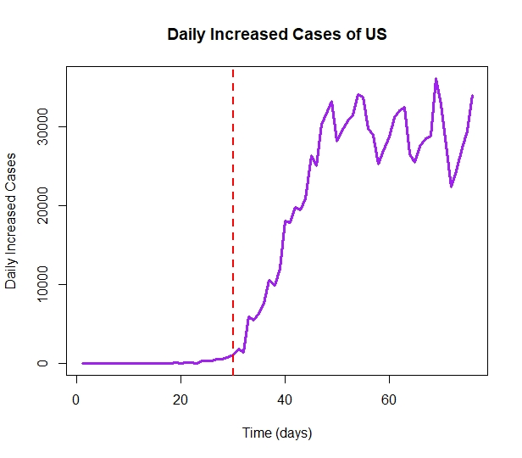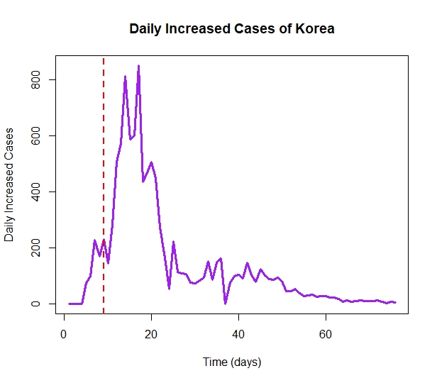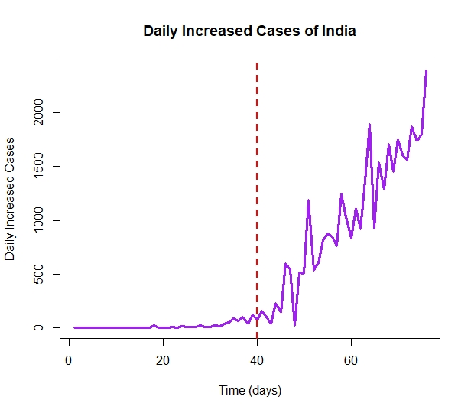

Sources:
For confirmed cases:
https://coronavirus.1point3acres.com/en
For mobility report:
https://www.google.com/covid19/mobility
For lockdown dates:
https://www.bbc.com/news/world-52103747

Organized Dataset & Code:
https://github.com/Lingggd/Datafest_ucla

